**UDAGRAM PROJECT DOCUMENTATION**

WEBLINK: [Udagram - Udacity Instagram Clone (udagr-webap-d6itubknf2la-328851360.us-east-1.elb.amazonaws.com)](http://udagr-webap-d6itubknf2la-328851360.us-east-1.elb.amazonaws.com/)

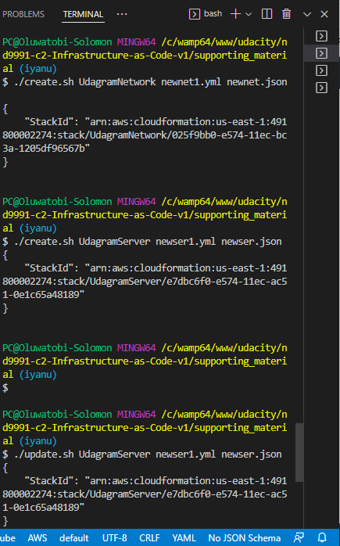

**CloudFormation scripts running**

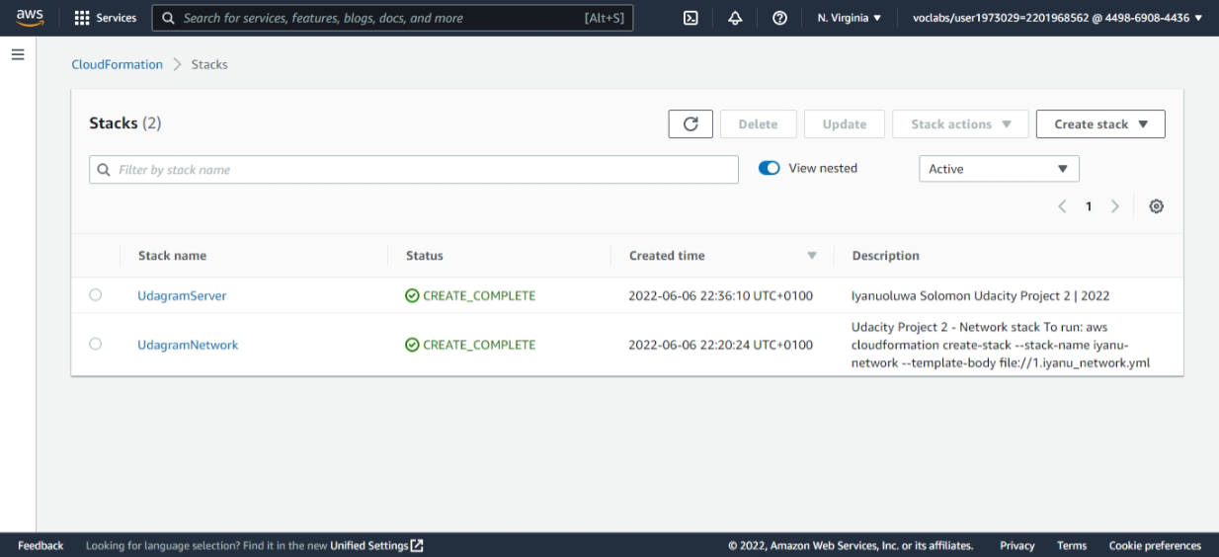

**CLOUDFORMATION SCRIPT EXECUTED**

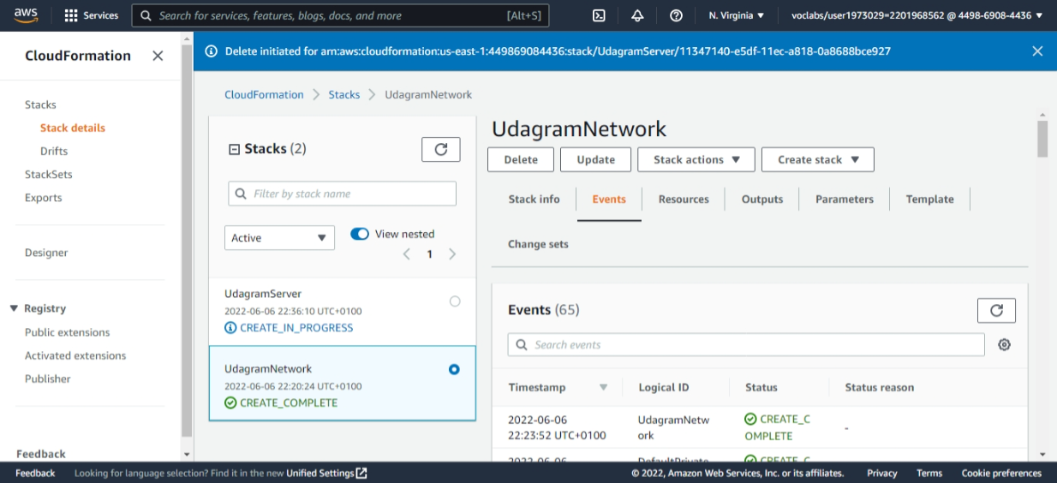

**UDAGRAM NETWORK EVENT**

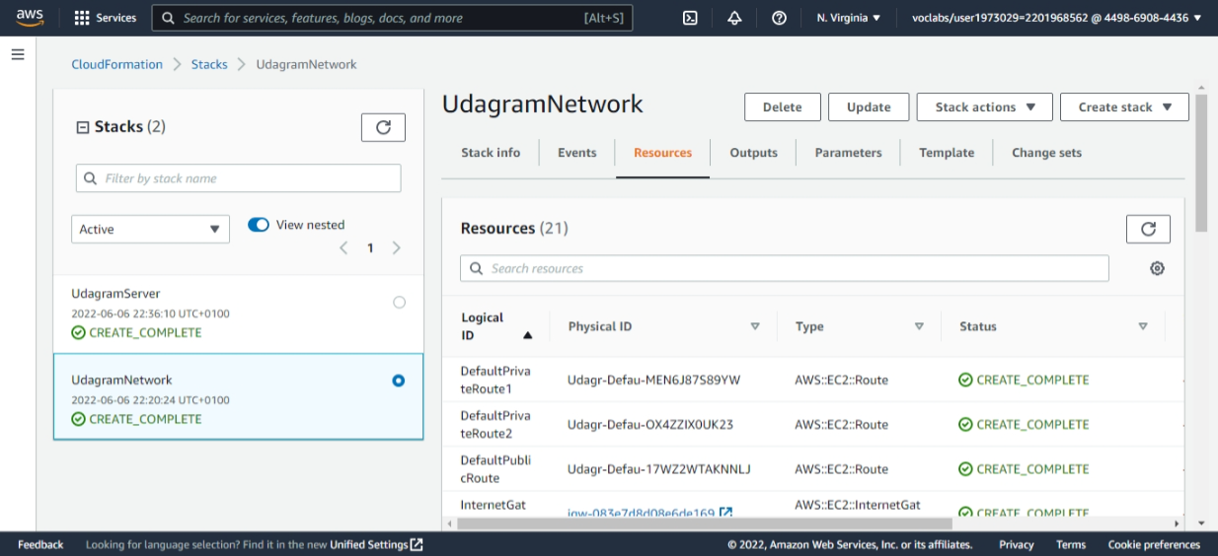

**UDAGRAM NETWORK RESOURCES**

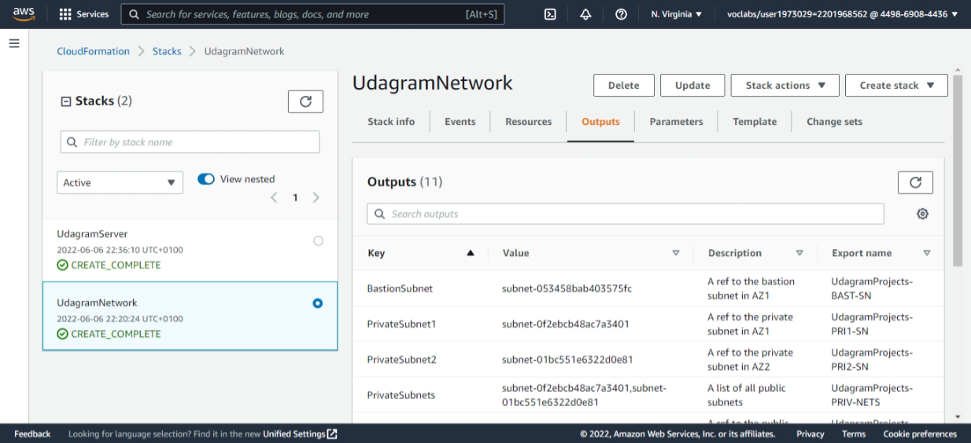

**UDAGRAM NETWORK OUTPUT**

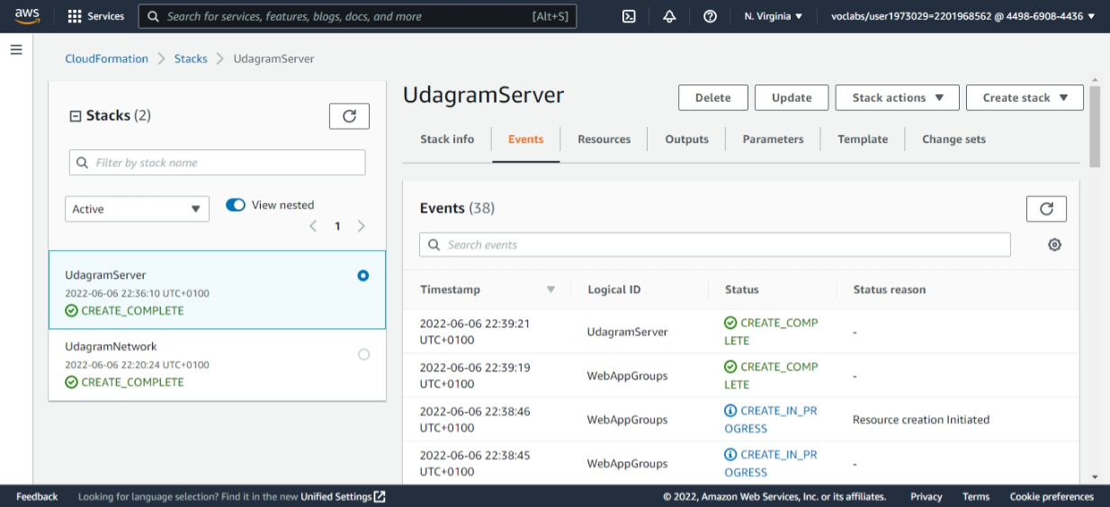

**UDAGRAM SERVER EVENT**

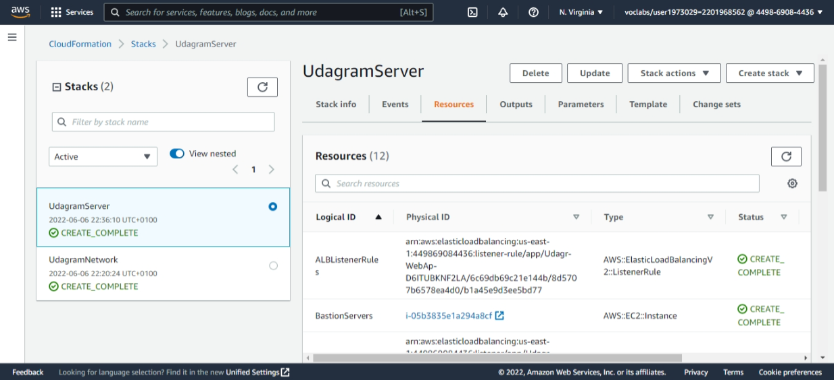

**UDAGRAM SERVER RESOURCES**

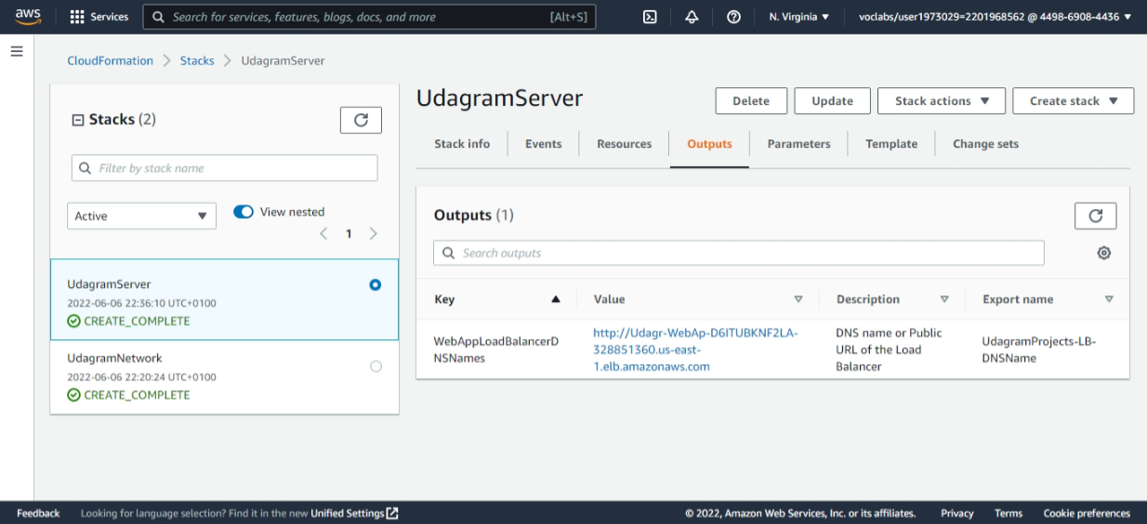

**UDAGRAM SERVER OUTPUT**



**UDAGRAM APPLICATION PAGE:** [Udagram - Udacity Instagram Clone (udagr-webap-d6itubknf2la-328851360.us-east-1.elb.amazonaws.com)](http://udagr-webap-d6itubknf2la-328851360.us-east-1.elb.amazonaws.com/)

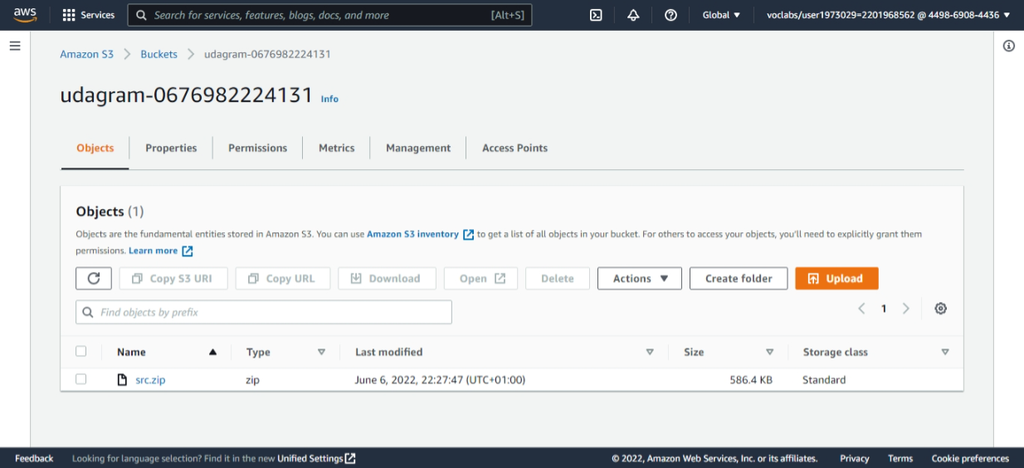

**UDAGRAM S3 BUCKET**

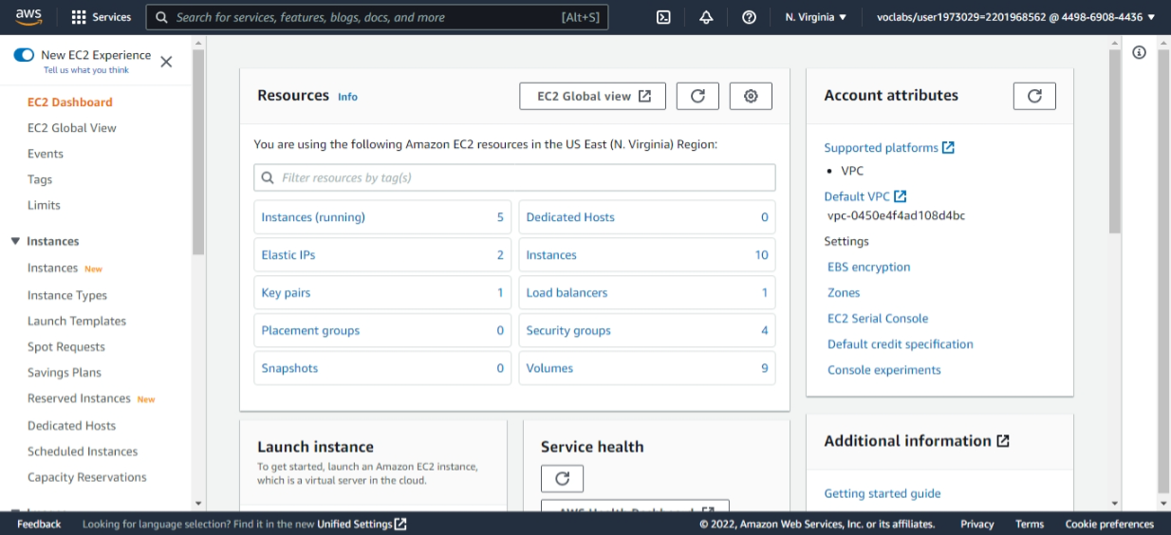

**EC2 DASHBOARD**

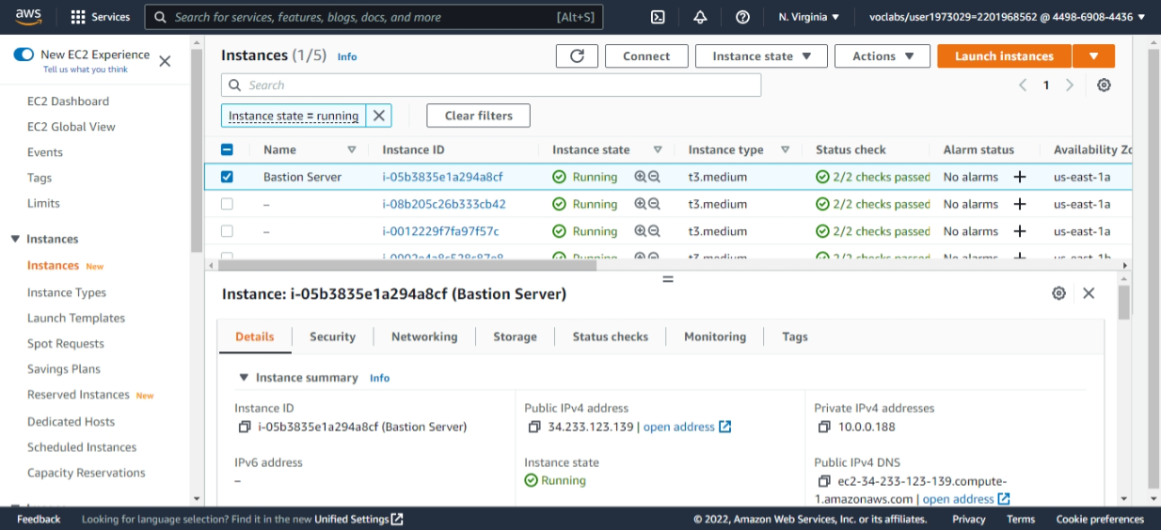

**UDAGRAM INSTANCE PAGE**

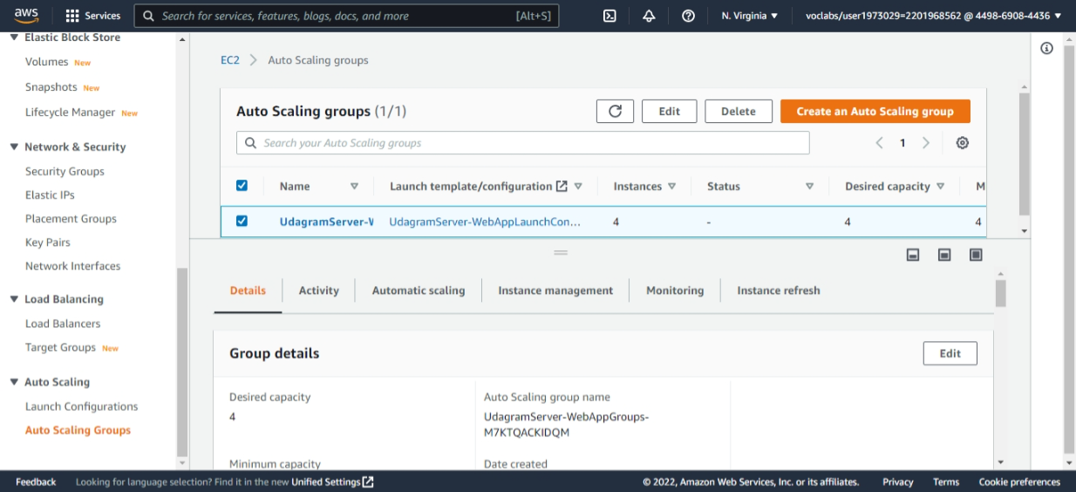

**UDAGRAM ASG**

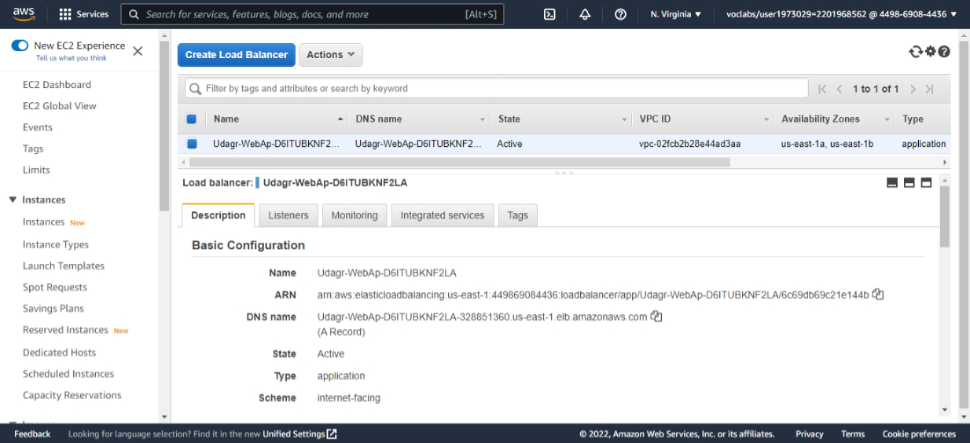

**UDAGRAM LOAD BALANCER**

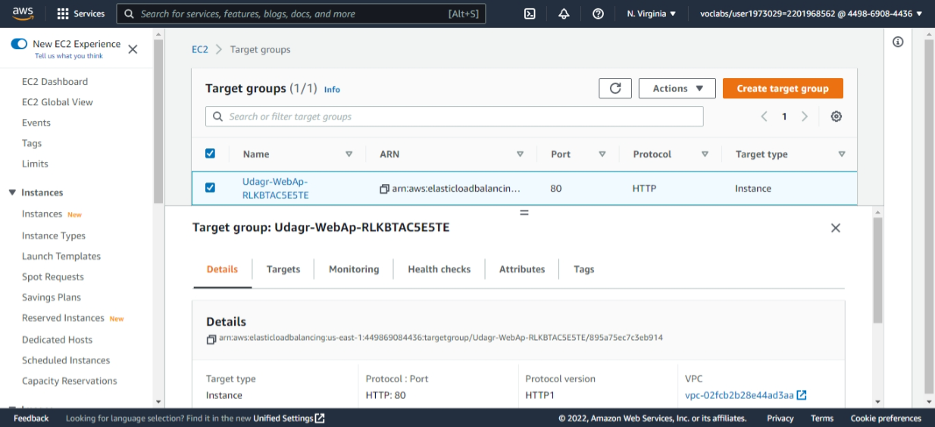

**UDAGRAM TARGET GROUP**